# init:Error

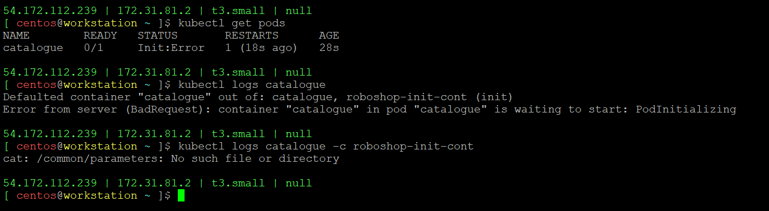

- Init container don’t have volume to store the /common/parameters
- IAM Role is not attached to Pod to pull the parameters values

